**Tracing Transitions: Analysis of Freight Dynamics Amidst**

**Shifting Populations in the 2020s**

Leah Black, Noah Black, Daniel Miller,

Jesse Springston, C. Noah Taylor

College of Engineering and Computer Science,

University of Tennessee at Chattanooga

November 10, 2023

# Introduction

In recent years, the United States of America has experienced substantial changes. Marked by the onset of the COVID-19 pandemic in late 2019, the nation has witnessed profound shifts in population distribution amidst a dynamic and often tumultuous economic landscape.

Given the prevailing uncertainties within the industry, the College of Engineering and Computer Science at the University of Tennessee at Chattanooga was approached with a collaborative request from FreightWaves, a Chattanooga-based freight price reporting agency, to analyze and illustrate the intricate interplay between the evolving population distribution of the 2020s and the flow of freight. Due primarily to the recent nature of the data being analyzed, findings during the course of this research were ultimately inconclusive in terms of establishing a direct relationship between population changes and direct changes in freight, warranting further research from different timeframes and perspectives. This writing seeks to illustrate and explain the potential trends and noteworthy findings established in the freight market as it relates to population change in the 2020s.

# Data Gathering & Preparation

The research utilized a dataset primarily comprised of publicly available Census Bureau data, accompanied by transportation flow data specific to Key Market Areas (KMAs) provided by the FreightWaves team. To streamline the focus of the study, the analysis was confined to data from the 2020s, predominantly centered around the period of 2020-2022. Notably, as of the research timeframe, data for the year 2023 was not yet accessible, thereby restricting the analysis to the most current and reliable information. The foundational dataset for assessing population changes emanated from the Census Bureau's county-level population data, offering a comprehensive overview of the total population by county for each U.S. state from July to July annually. The transportation flow data from FreightWaves provided crucial insights into the volume of deliveries organized into pairs of origin KMA locations and their respective destination KMAs within the specified time frame, though this data was limited to that which FreightWaves had contract data available for. While acknowledging the dataset's inherent limitations, its substantial sample size facilitated a robust analysis of transportation flow changes to KMAs in relation to population shifts.

To facilitate precise comparisons between Census population data at the county level and FreightWaves transportation data specific to KMAs, a meticulous mapping process was undertaken. Counties were systematically linked to the KMAs encompassing them, and aggregate figures were computed for each respective KMA. In instances where a county spanned two KMAs, it was incorporated into the KMA with the higher population density, ensuring a methodical approach to data integration.

Initial investigations revealed challenges in discerning statistical significance in the fluctuations of KMA population and freight volume on an annual basis. To enhance precision in identifying KMAs with statistical relevance, this research focused its analysis on the cumulative changes in both population and freight volume spanning the years 2020 to 2022. To refine the scope of this research, the Top 20 KMAs were identified and placed under greater scrutiny based on the highest cumulative population changes observed between 2020 and 2022, encompassing both positive and negative variations.

The subset of the Top 20 KMAs illustrates the drastic transformation in demographic and economic dynamics that have unfolded in the United States since 2020. At one end of the spectrum, NY_BRN, CA_SFR, CA_FRS, and IL_CHI have seen the most pronounced population decreases, accompanied by significant freight volume losses, highlighting shifting dynamics within major urban environments. In contrast, Texas showcases a different narrative. TX_DAL, TX_AUS, TX_HOU, and TX_ANT not only exhibit substantial population growth, but also maintain a relatively steady freight flow. This combination serves as an emblem of the state's expanding influence and robust economic activities. Similar to the trend in Texas, the Southeastern region, represented by nine Top KMAs, embodies a region enriched by substantial migratory growth. FL_LAK stands out, recording the largest population increase observed across the entire nation, paired with a modest growth in freight volume. This pattern of combined demographic and economic growth extends, to varying degrees, throughout the region, which also includes FL_JAX, FL_MIA, GA_ATL, NC_CHA, NC_RAL, SC_GRE, SC_COL, and TN_NAS. In the western region, AZ_PHO, ID_TWI, and UT_SLC emerge prominently within the Top 20 KMAs. These areas have experienced significant population surges, likely drawing former California residents due to their geographical proximity. Particularly, Phoenix stands out by not only witnessing a rise in population, but also demonstrating increased freight activity, showcasing its vibrant growth and robust economic involvement.

Collectively, these Top 20 KMAs not only reflect the country's shifting population centers, but also serve as hubs of resilience amidst nationwide fluctuations in freight volumes. Their resilience resides in their roles as pivotal points in the nation's logistics network, indicating that even as freight volumes may oscillate nationally, these KMAs retain a steadiness due to their strategic importance. Acknowledging this pattern offers a valuable perspective: while some regions navigate the complexities of decline, others are burgeoning, and yet, these hubs maintain a reliable constancy in freight flow, pivotal for the understanding of economic stability and forecasting. The highlighted contrast between the ebbs in urban centers and the flows in emerging hotspots sets the stage for comprehensive analysis into these changes and their wider significance for supply chain logistics and strategic infrastructure planning across the nation.

# Scatter Plots

Scatter plots of population and freight changes during the 2020 to 2022 time frame were developed. The purpose of these scatter plots was to offer a simple, visual representation of population and freight change relationships. Each of the 135 KMAs was plotted in the scatter plots with the size of the point representing the absolute value change in population from 2020 to

2022; larger points indicate greater population changes, whether positive or negative. Additionally, the points were color-coded according to the quadrant they fell into, which enhanced the clarity and distinction of the different scenarios. For instance, green points illustrate KMAs that experienced growth in both population and freight, suggesting a positive trend in both metrics. Conversely, red points mark KMAs that saw declines in both variables. The remaining two scenarios are represented by yellow points, which denote KMAs with population growth coupled with freight loss, and blue points, which identify areas where freight volume grew even as the population shrank. This visualization strategy allows for a nuanced assessment of KMA dynamics at a glance, highlighting both the direction and magnitude of population and freight changes.

Four scatter plots were created in total, each utilizing different variables in the dataset to investigate the relationship between changes in population and freight among KMAs. To determine the scatter plot that offered the most insight for analysis, the Pearson correlation coefficient for each scatter plot was calculated to measure the strength and direction of the relationship between the population and freight changes. The scatter plot showing the highest Pearson correlation coefficient, which was approximately 0.124, was selected as the primary scatter plot for further analysis. This plot used the variables “KMA Population Change 2020-

2022” as the independent variable and “KMA Freight Percent Change 2020-2022” as the dependent variable, indicating a weak positive linear relationship between these two variables. In comparison, the Pearson correlation coefficient between "KMA Population Change 2020-2022" and "KMA Freight Change 2020-2022" was approximately 0.031, signifying a very weak positive relationship, and the coefficient between "KMA Population Percent Change 2020-2022"

and "KMA Freight Percent Change 2020-2022" was about 0.039, also indicative of a very weak positive relationship when considering their percentage changes over the same period.

## KMA Population Change vs. KMA Freight Percent Change (2020-2022) Scatter Plot

Building on the initial analysis, a deeper examination was conducted on the Top 20

KMAs. When focusing on this subset, the correlation between “KMA Population Change 2020-

2022” and “KMA Freight Percent Change 2020-2022” showed a significant increase, with the Pearson correlation coefficient soaring to approximately 0.511. This marked uptick from the general coefficient of 0.124 for all 135 KMAs indicates a much stronger moderate positive linear

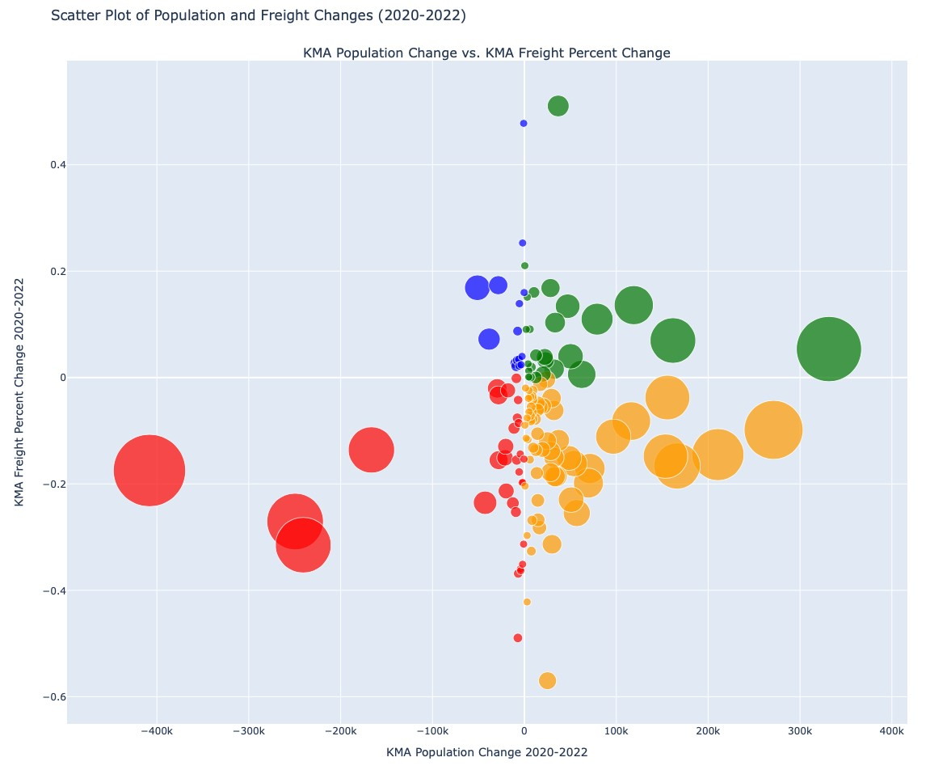

relationship, accentuating the importance of closely analyzing these Top 20 KMAs. The “KMA Population Change vs. KMA Freight Percent Change” scatter plot aligned with the Top 20 KMA selection of the project based on the “KMA Population Change 2020-2022” independent variable and “KMA Freight Percent Change 2020-2022” as the dependent variable. Furthering the analysis, this scatter plot remained instrumental by also offering insight into interesting outliers in the data. Many of the relationship quadrants presented themselves in clusters of KMAs with similar population and freight changes with the exception of a few. The existing outliers opened up areas of analysis that could be investigated further to offer more insight into the contributing factors of population and freight change.

The most notable outliers outside of the Top 20 KMAs in the primary scatter plot include the following KMAs: NC_GRE (Greenville, North Carolina), VA_ROA (Roanoke, Virginia), and FL_TAL (Tallahassee, Florida). These KMAs are outliers in terms of “KMA Freight Percent

Change 2020-2022”, seeing higher amounts of freight percent change across 2020 to 2022 than all other KMAs. The NC_GRE and VA_ROA KMAs experienced positive freight percent change, and the FL_TAL KMA experienced negative freight percent change. Further analysis offered insight into the contributing factors of these outlier KMAs. In spite of an increase in population by 3%, FL_TAL KMA experienced a loss of -56% in freight percent change across 2020 to 2022, possibly due to hurricanes and hurricane seasons that limited domestic freight transportation flow, marking weather and natural disasters as a contributing factor that can influence freight change. NC_GRE and VA_ROA KMAs both increased in freight percent change by nearly 50% across 2020 to 2022 in spite of featuring only marginal changes in population. Some potential contributing factors include economic growth, industry expansion, and infrastructure development or supply chain changes - notably, both of these KMAs are home to large scale automotive and equipment manufacturers and suppliers, including IAC in North Carolina and General Electric in Roanoke, necessitating large volumes of freight.

# Line Graphs

To analyze the Top 20 KMAs further, line graphs were created with the purpose of visualizing population and freight changes on a month to month basis from January 2020 to

December 2022. A line graph was created for every KMA in the Top 20, using variables “Freight

% of Total” and “Population % of Total”. By using a percentages of totals to normalize the data, we can more accurately analyze the specific KMA in relation to the entirety of national KMAs.

A separate line graph was created to display the freight and population percent change across January 2020 to December 2022 for all national KMAs. The USA Freight and Population Percent Change (2020-2022) line graph gives insight into the freight change and population change for a certain month pertaining to all KMAs. After analysis on the line graphs, the existence of an interesting correlation was found in April 2020. There is a decrease of 29.7% in freight percent change during April of 2020, likely attributed to the onset of COVID-19 effects on freight. When looking at the top 5 KMAs out of the Top 20 (NY_BRN, FL_LAK, TX_DAL, CA_FRS, CA_SFR), there is a spike in “Freight % of Total” during April of 2020. This trend was observed across 17 of the Top 20 KMAs during this timeframe, showcasing sharp increases in freight percentage share while the entire KMA market was at its lowest point. The conclusion can be drawn that these Top 20 KMAs began to be the leaders or hubs in freight transportation flow during the onset of COVID-19 in the United States, potentially transporting the necessities required during the pandemic.

**USA Freight and Population Percent Change Line Graph (2020-2022) and Top 5 KMA Freight and Population Percent of National Line Graph (2020-2022)**

Looking at the most recent dates on the USA Freight and Population Percent Change (2020-2022) line graph, analysis shows that freight percent change decreased from August 2022 to December 2022. This trend strongly indicates that the freight market is experiencing a considerable state of decline as of December 2022. Further research of different timeframes will be necessary to determine where freight percent change is as of November 2023.

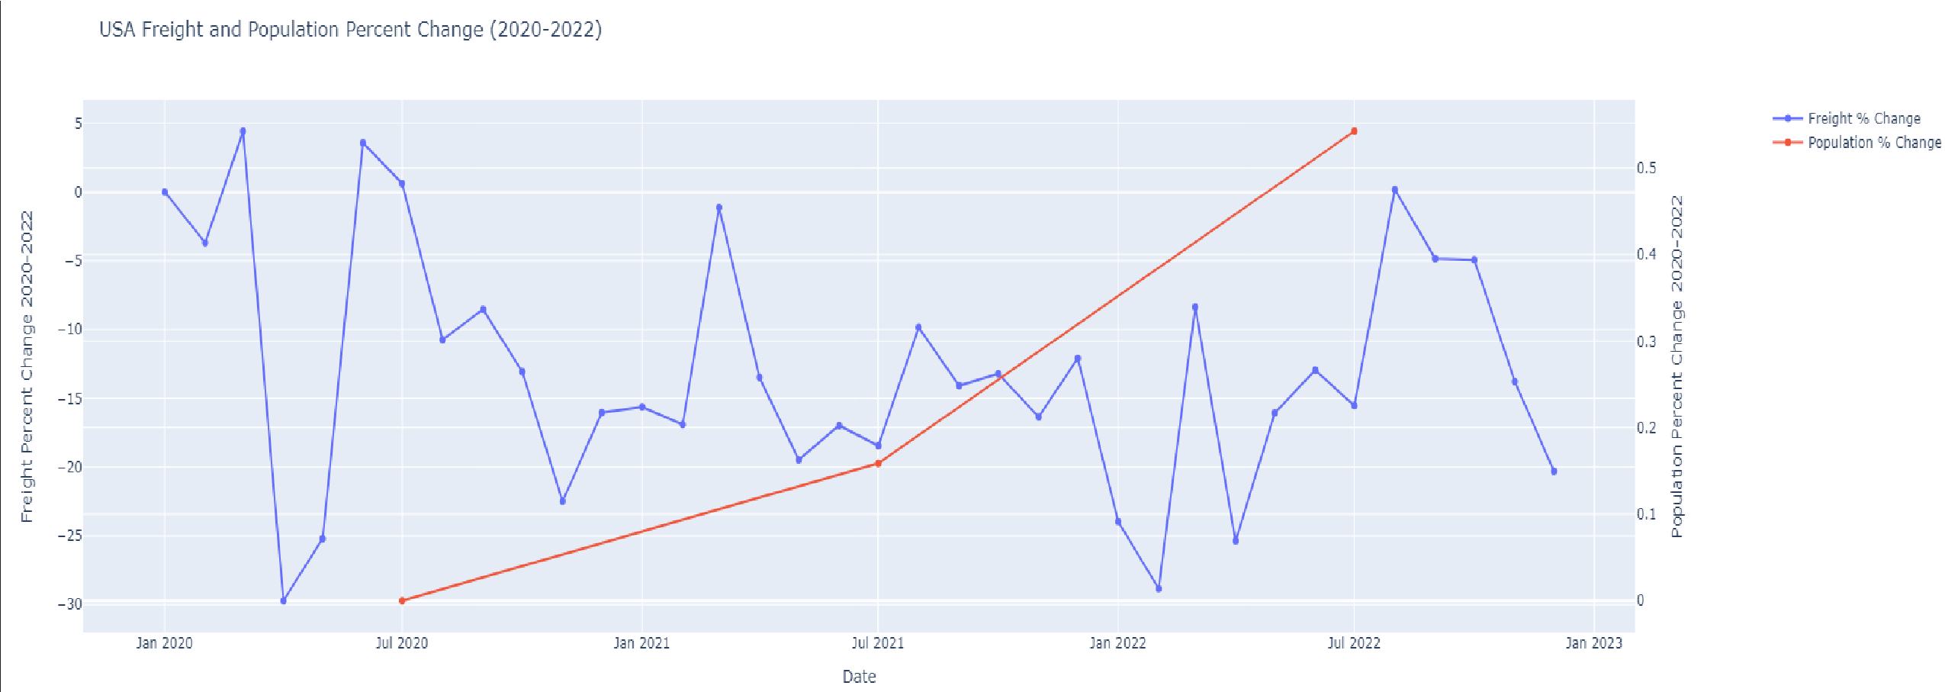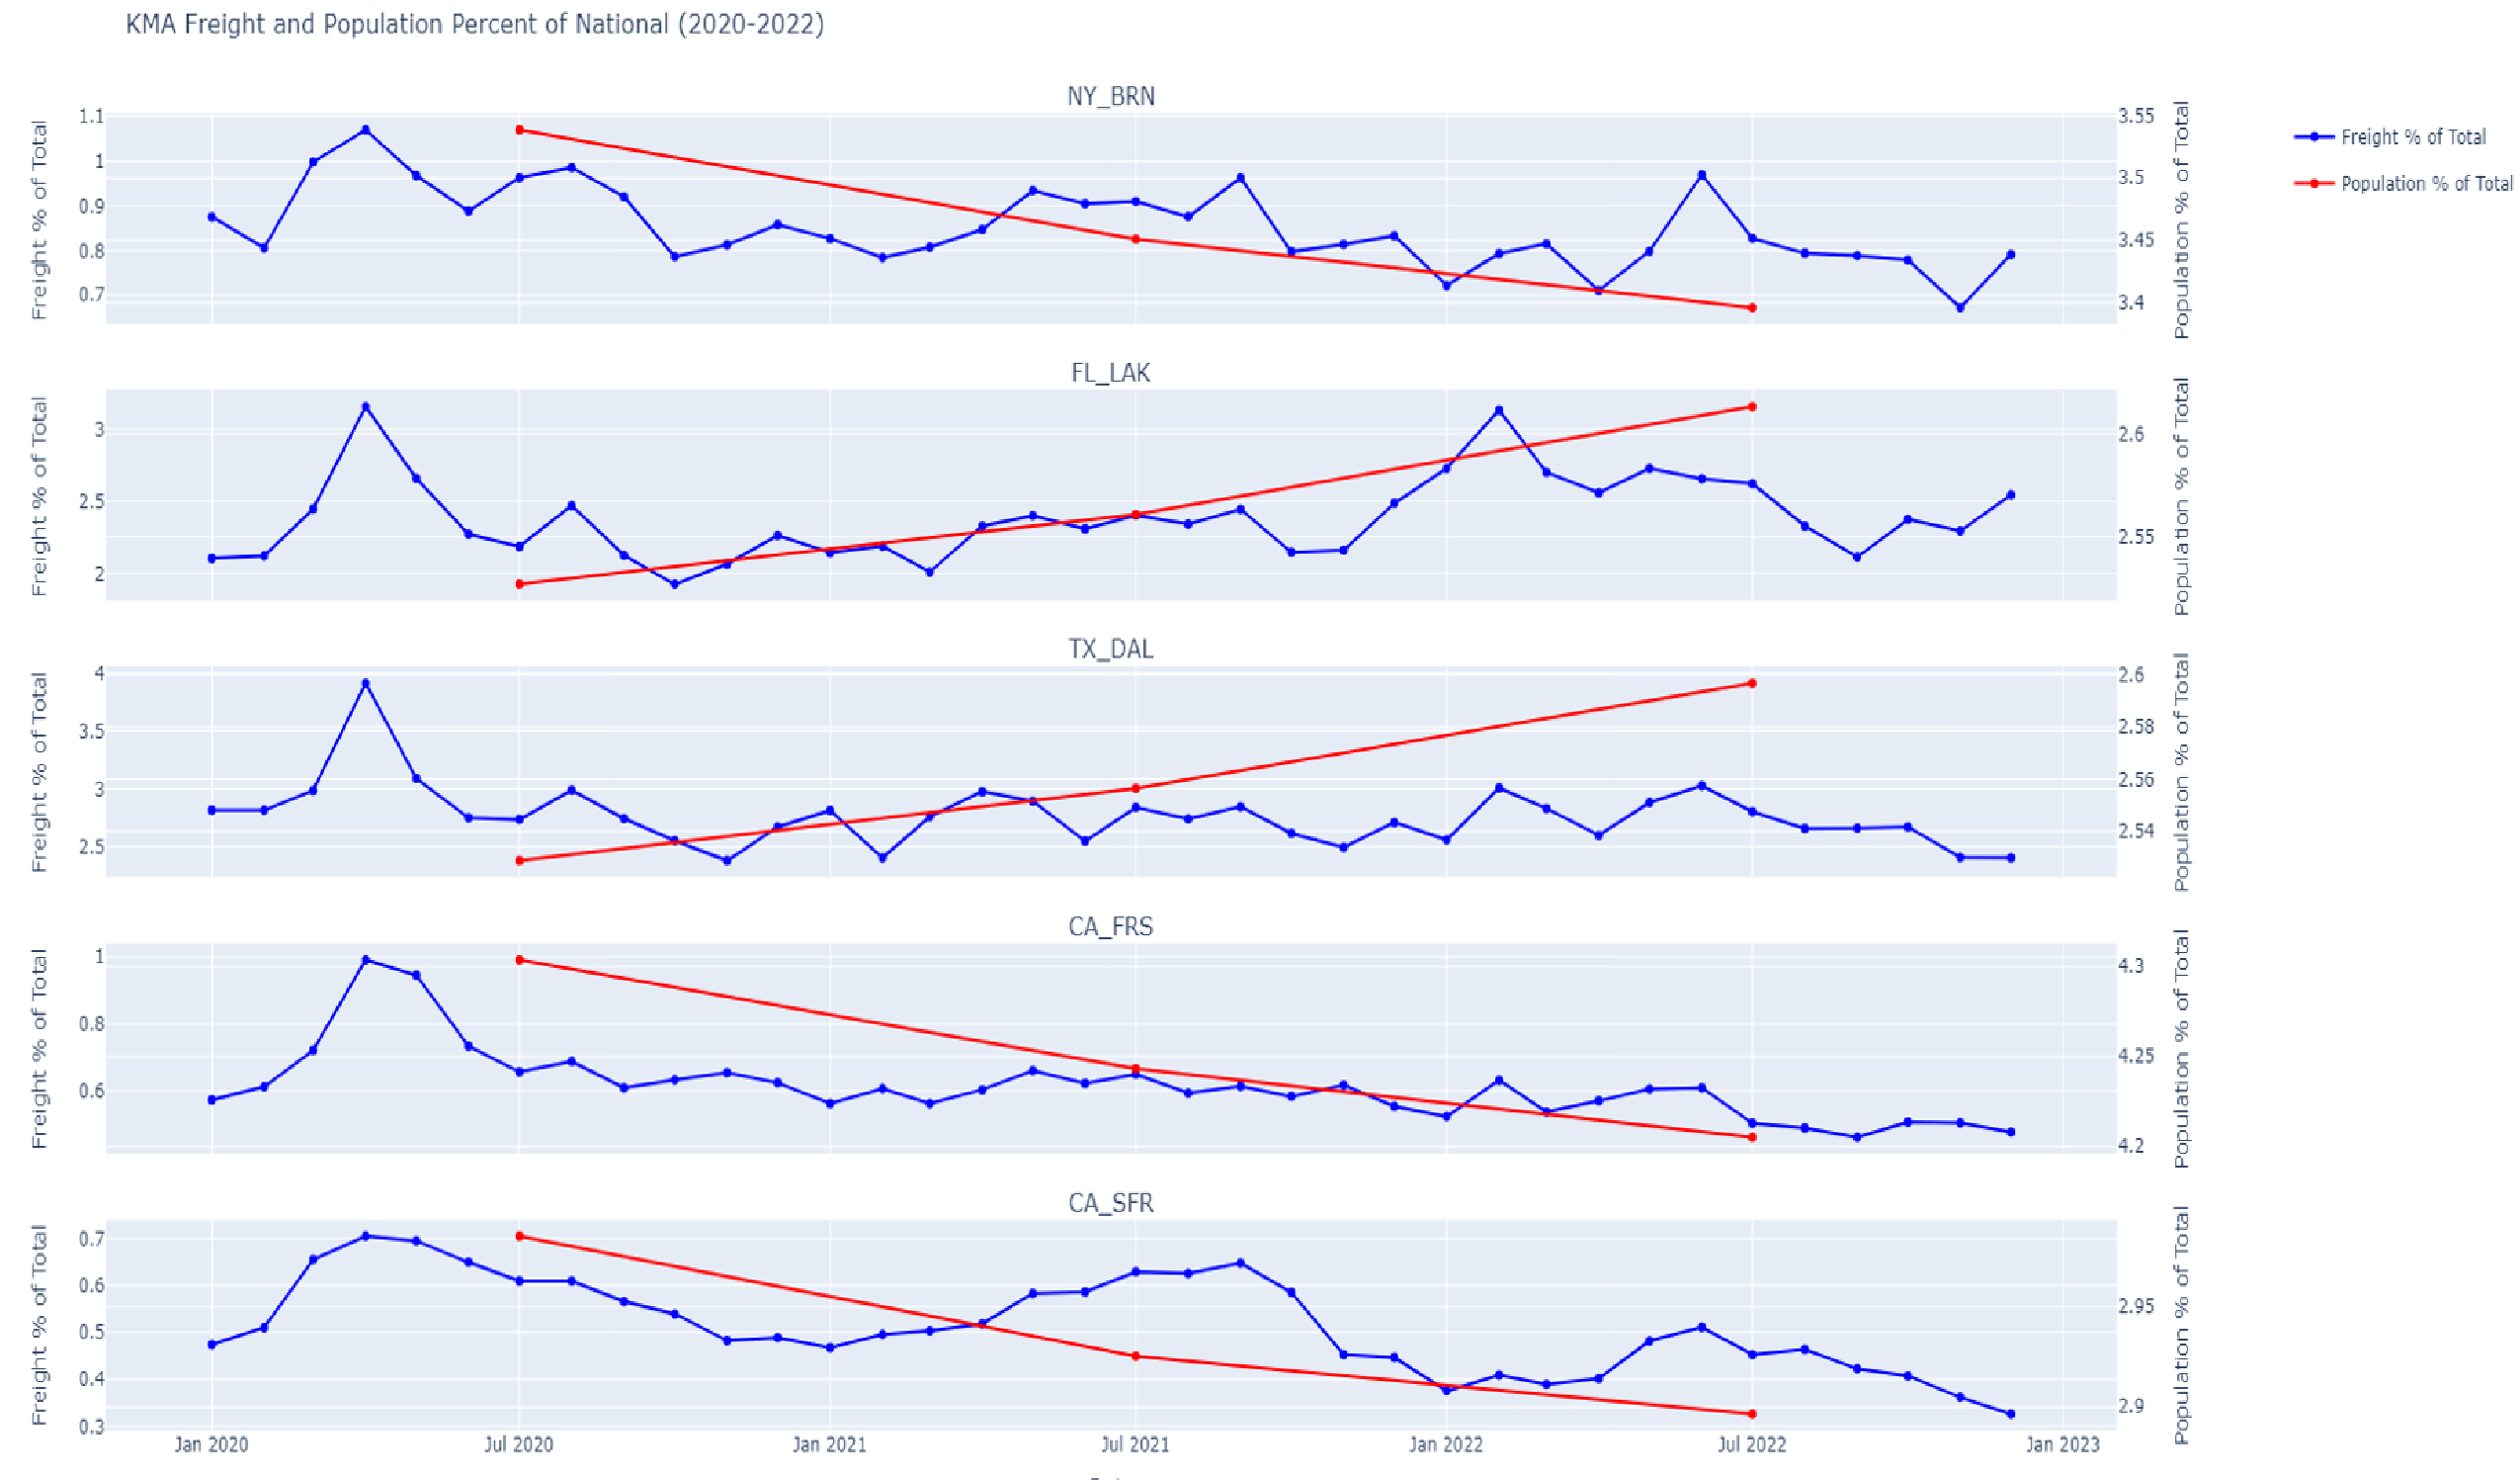

Overall, the line graphs developed offered themselves as an aid throughout the project to dive deeper into KMAs on a month-by-month basis to offer insight that could assist in finding contributing factors of change. These line graphs did not necessarily establish any displays of population-freight relationships in themselves but more so assisted in finding interesting KMA freight changes across the 2020 to 2022 timeline.

# Bar Charts

Bar charts were created for the purpose of visualizing the scale of percent changes in freight and population from 2020 to 2022 for all national KMAs. After analyzing the KMA Freight Percent Change (2020-2022) bar chart, it was found that only 41 out of 135 KMAs saw an increase in KMA Freight Percent Change from 2020 to 2022. The majority of KMAs saw a decrease in KMA Freight Percent Change from 2020 to 2022, ranging from 0.1% to 57% decrease. This analysis leads to the conclusion that freight percentages from 2020 to 2022 were primarily decreasing for the majority of national KMAs. Given that nearly 70% of KMAs are experiencing significant declines in freight volumes, the ramifications for freight infrastructure and supply chain management are profound. This pattern of reduced freight activity reflects extensive and deep-rooted economic transformations. The falling freight percentages underscore the necessity for adaptable strategies in both regional and national freight planning to safeguard resilience and efficiency within logistics networks as market conditions continue to evolve.

## KMA Freight Percent Change (2020-2022) Bar Chart

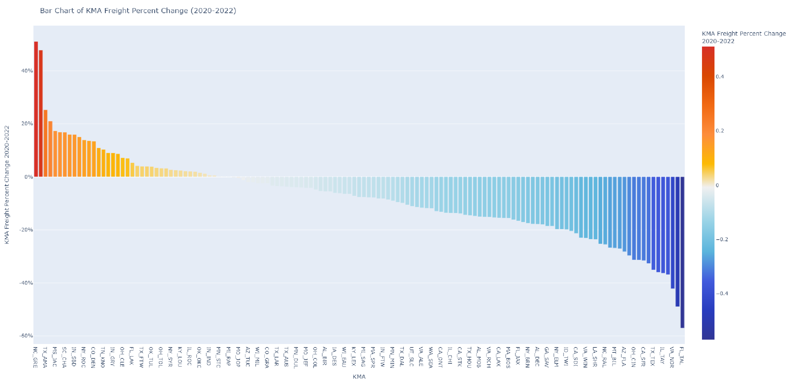The “KMA Population Percent Change (2020-2022) bar chart can be analyzed for use in comparison with the “KMA Freight Percent Change (2020-2022)” bar chart. In contrast to the freight change bar chart, the percentage change bar chart saw increases for the majority of KMAs. After analyzing the KMA Population Percent Change (2020-2022) bar chart, it was found that 89 out of 135 KMAs saw an increase in KMA Population Percent Change from 2020 to 2022, ranging from 0.01% to 5.4%. This analysis leads to the conclusion that population percentages from 2020 to 2022 were primarily increasing for the majority of national KMAs. This upward trend in demographics may reflect evolving regional developments and potentially indicates a strengthening or concentration of consumer bases, which could carry positive prospects for economic activities, despite the current freight volume setbacks.

## KMA Population Percent Change (2020-2022) Bar Chart

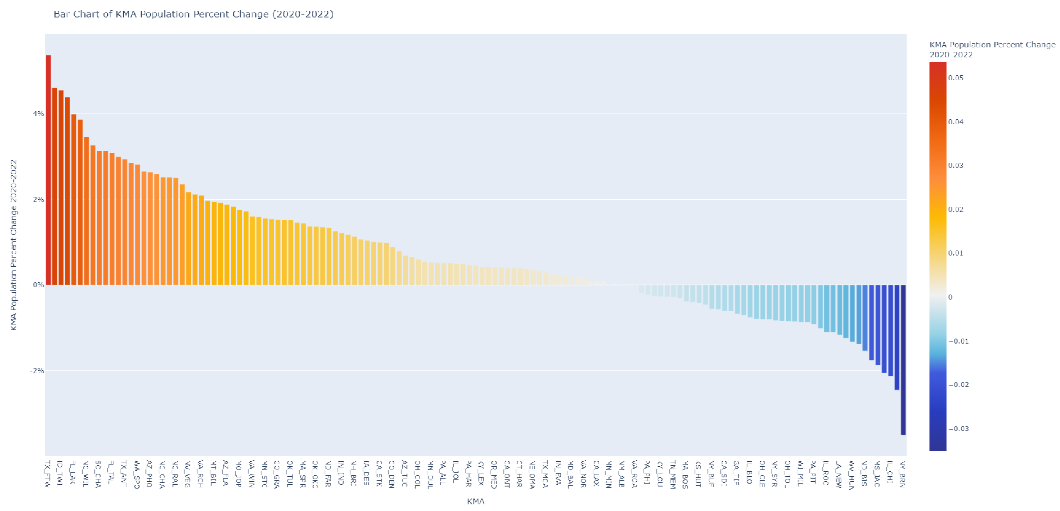Comparing bar charts for KMA Freight and Population Percent Change from 2020 to 2022 reveals a contrast in trends across national KMAs. While only 30% of KMAs showed an increase in freight volumes, with the rest experiencing declines, population figures tell a different story with over 65% of KMAs witnessing population growth. The divergent patterns suggest while demographics are strengthening, freight movement is not keeping pace, implying significant consequences for logistics and highlighting the necessity for dynamic freight planning in response to evolving economic conditions.

# Maps

Choropleth maps were created using the Python Folium library, with a main purpose of identifying KMA population-freight relationships and KMAs where freight has likely been impacted by population. The main idea behind the Folium maps was to incorporate multiple maps with multiple data layers which can be toggled to allow for user-based selection. Userbased selection allows for a wide range of analysis, where variable maps can be chosen and compared selectively. The following maps were created: County Lines, KMA Lines, Top 20 KMA Population 2020, Top 20 KMA Population 2021, Top 20 KMA Population 2022, All

KMA 2020-2022 Population Change, Top 20 KMA Population Percent Change 2020-2022, Top 20 KMA Population Total Change 2020-2022, Top 20 KMA Freight Percent Change 2020-2022, and Top 20 KMA Freight Total Change 2020-2022. The “County Lines” and “KMA Lines” maps were created as a means to layer on top of any other toggled map and offer added insight, whether that be county breakdowns or KMA breakdowns. The “Top 20 KMA Population” for 2020, 2021, and 2022 maps were created as a breakdown of the population change maps that will primarily be used, to allow for a visual of population during the years of change.

A 2020 to 2022 population change map was created for the entirety of all national KMAs. The national KMAs population change map primary purpose was to offer insight into population change outside of the Top 20 KMAs focused on in this project. Considering that the Top 20

KMAs were chosen off of 2020-2022 total population change, the “All KMA 2020-2022 Population Change” map visualizes where the Top 20 KMAs were selected from.

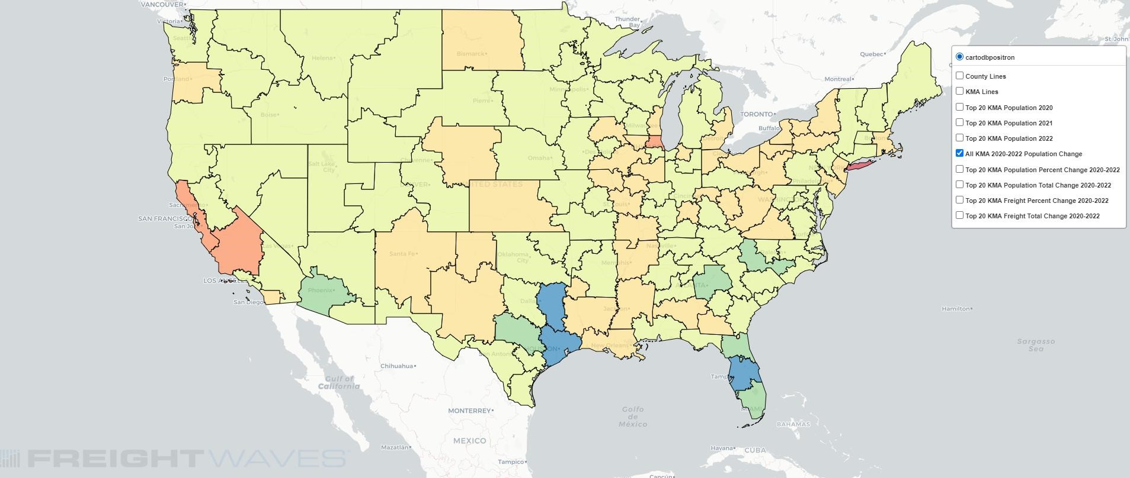

## All KMA 2020-2022 Population Change Map

To identify KMA population-freight relationships and KMAs where freight has likely been impacted by population, this project focused on comparing the “Top 20 KMA Population Total Change 2020-2022” and “Top 20 KMA Freight Percent Change 2020-2022” maps, the variables previously compared in the primary scatter plot and discussed to have the highest Pearson correlation coefficient. From the Top 20 KMAs, there were 4 negative-negative, 5 positive-positive, 11 positive-negative population-freight relationships.

**Top 20 KMA Population Total Change 2020-2022 Map**

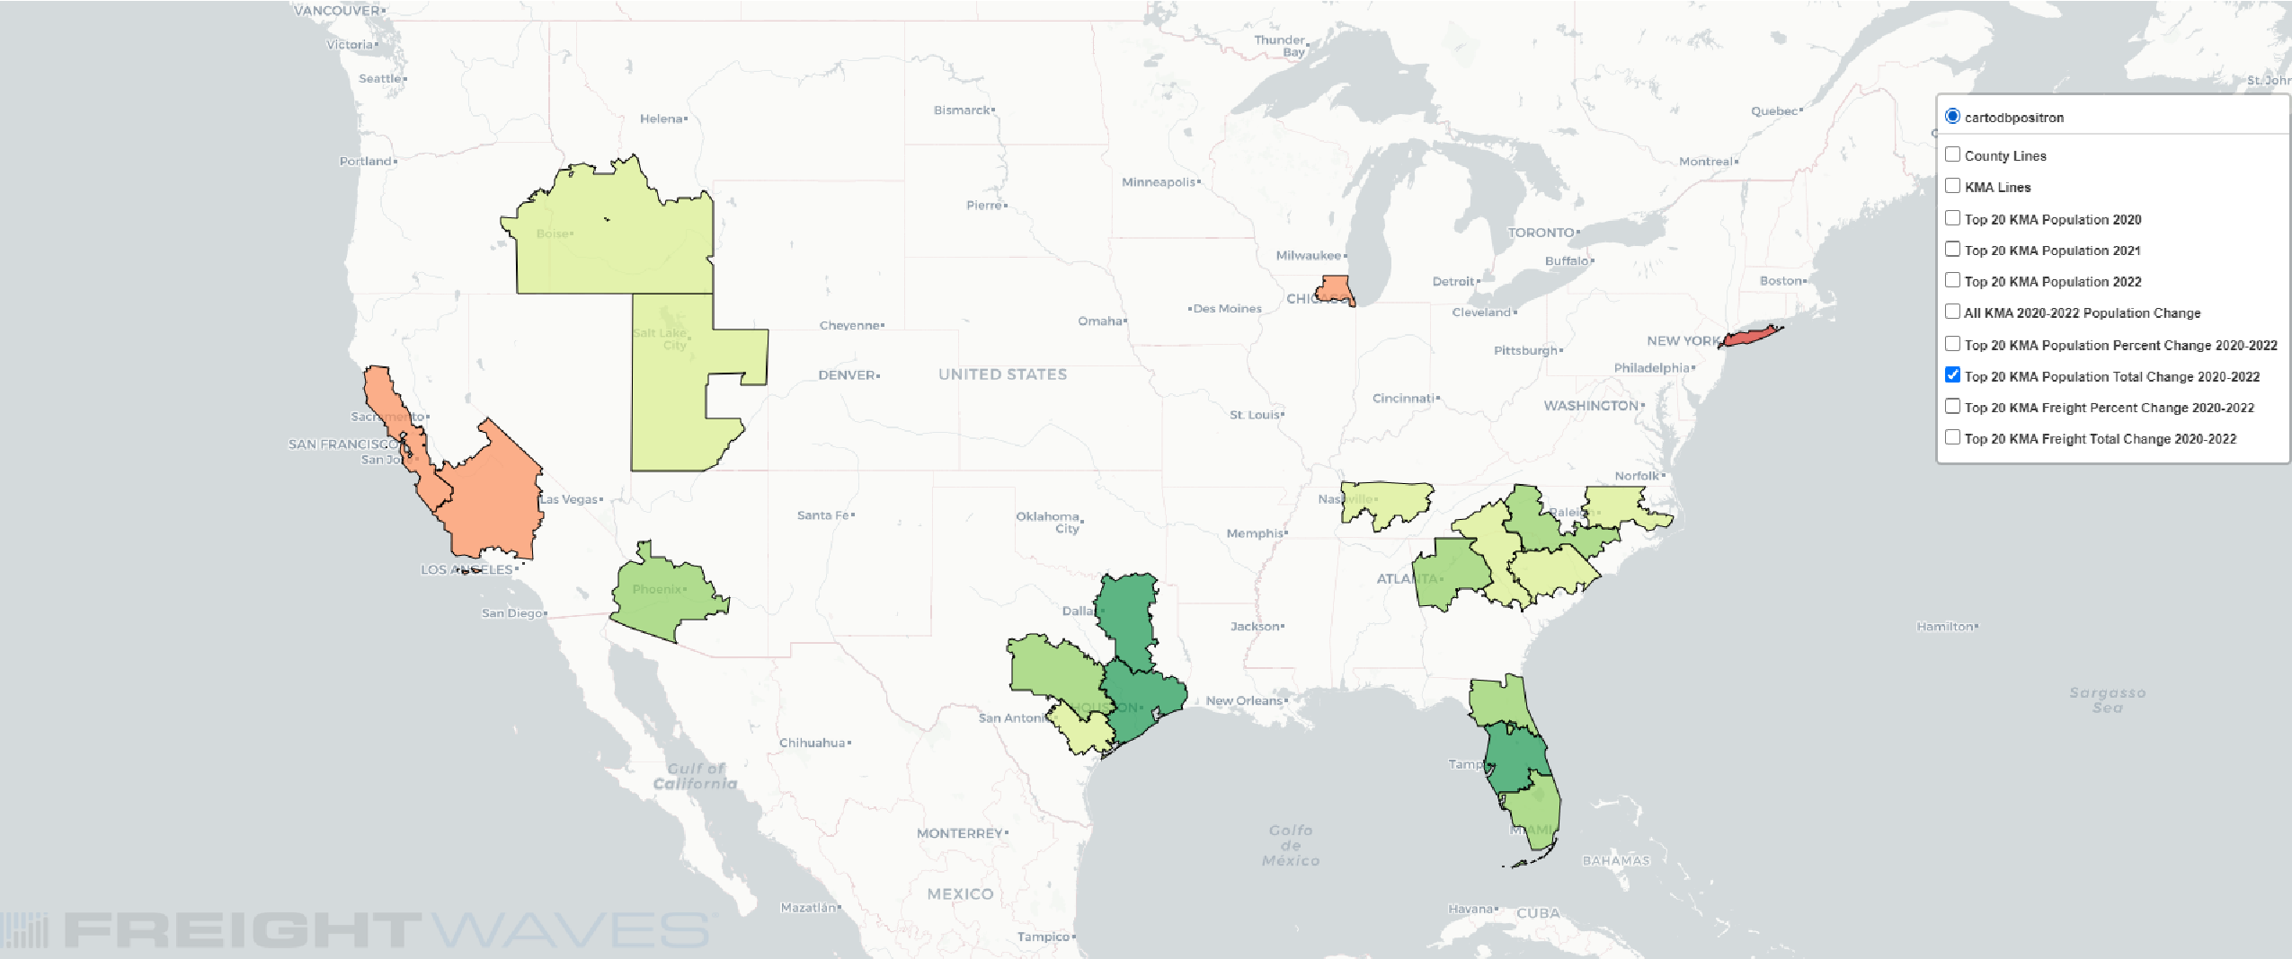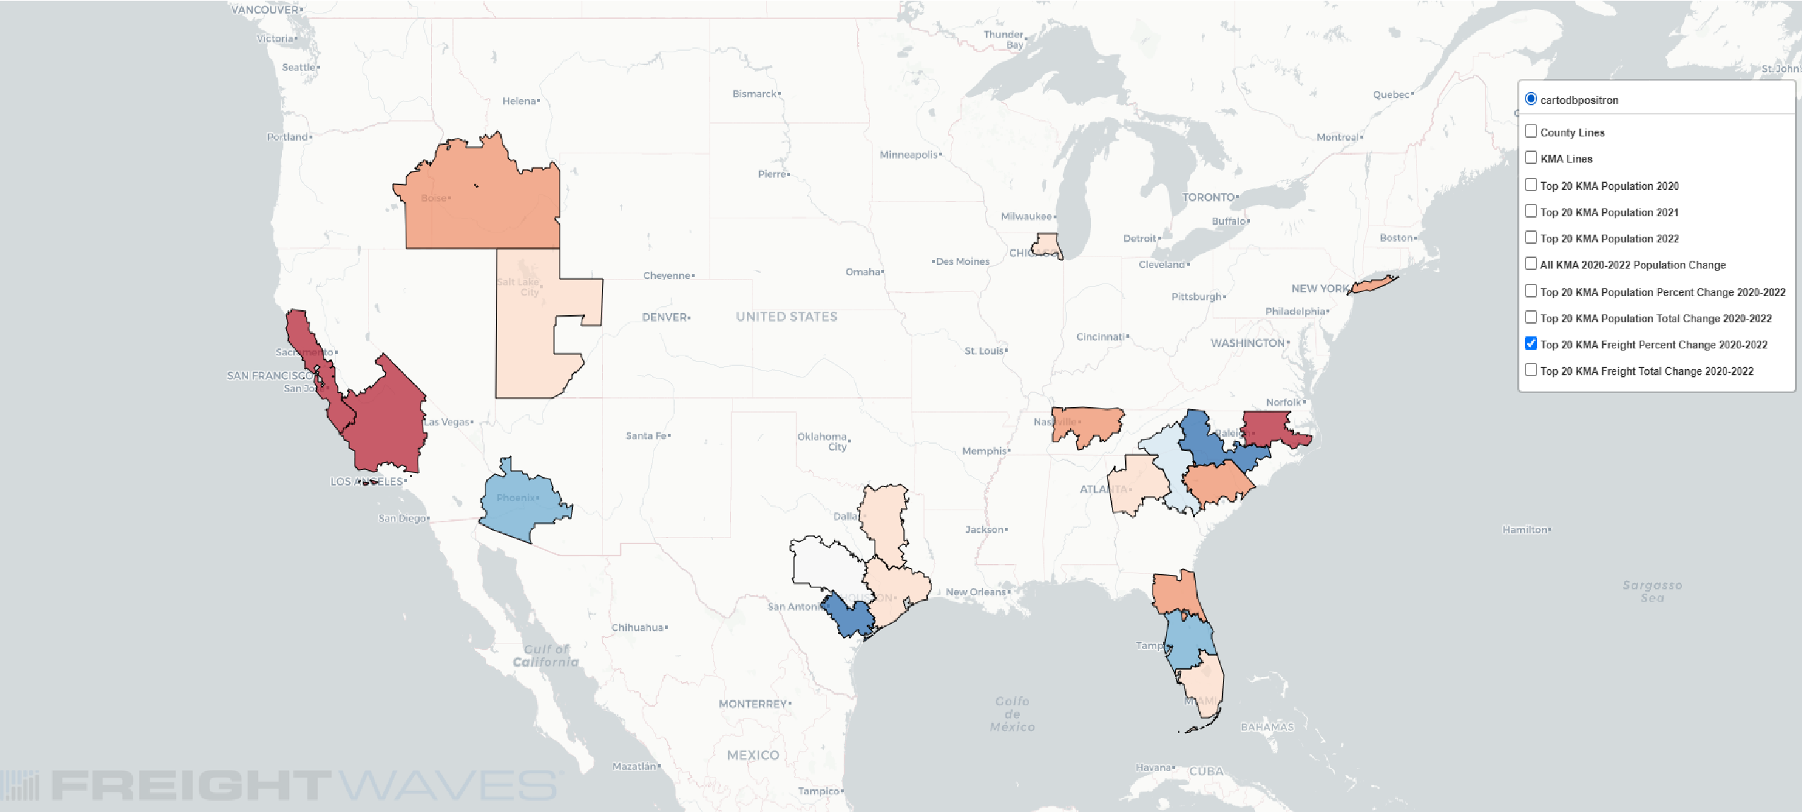

## Top 20 KMA Freight Percent Change 2020-2022 Map

Beyond the population-freight relationships found, we can identify clusters on the maps to potentially find contributing factors that can be used to determine if any of the Top 20 KMA population-freight relationships include population impacts on freight. For example, the

Southeast clusters/KMAs appear to be gaining population from 2020 to 2022 and the larger

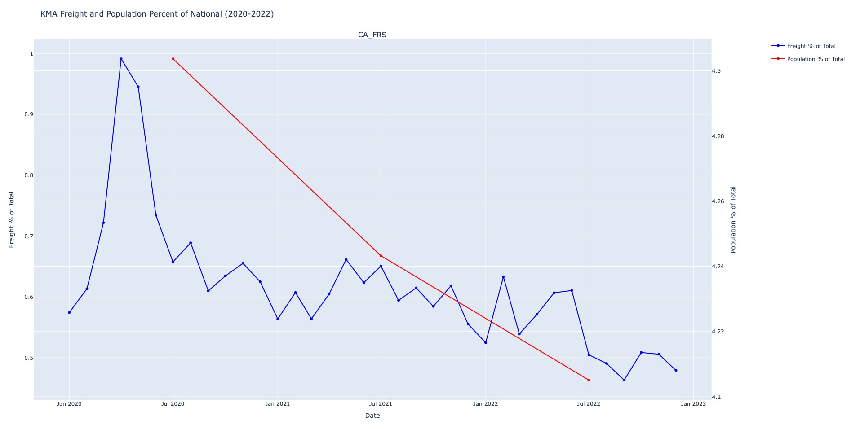KMAs in the West appear to be losing population from 2020 to 2022. Focusing on the larger KMAs losing population, San Francisco and Fresno, they also appear to be greatly decreasing in freight percent change from 2020 to 2022, -31.51% and -27.07%, respectively. Revisiting the CA_FRS and CA_SFR line graphs discussed previously, we can see a month-to-month visual that shows freight decrease following population decrease, with some areas of attempted recovery, but nonetheless visualizing an impact on freight by population considering the freight variable beginning to decrease where population begins to decrease. The CA_SFR and CA_FRS KMAs appear to be KMAs which exhibit possible examples of population impacts on freight, with a considerable loss in population and a corresponding loss in percentage of freight as demand for consumer goods decreases.

## CA_FRS and CA_SFR KMA Freight and Population Percent of National (2020-2022) Line Graphs

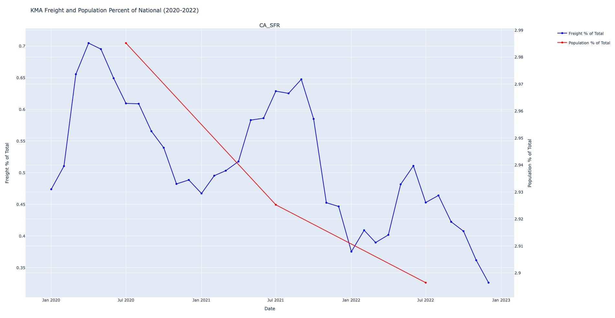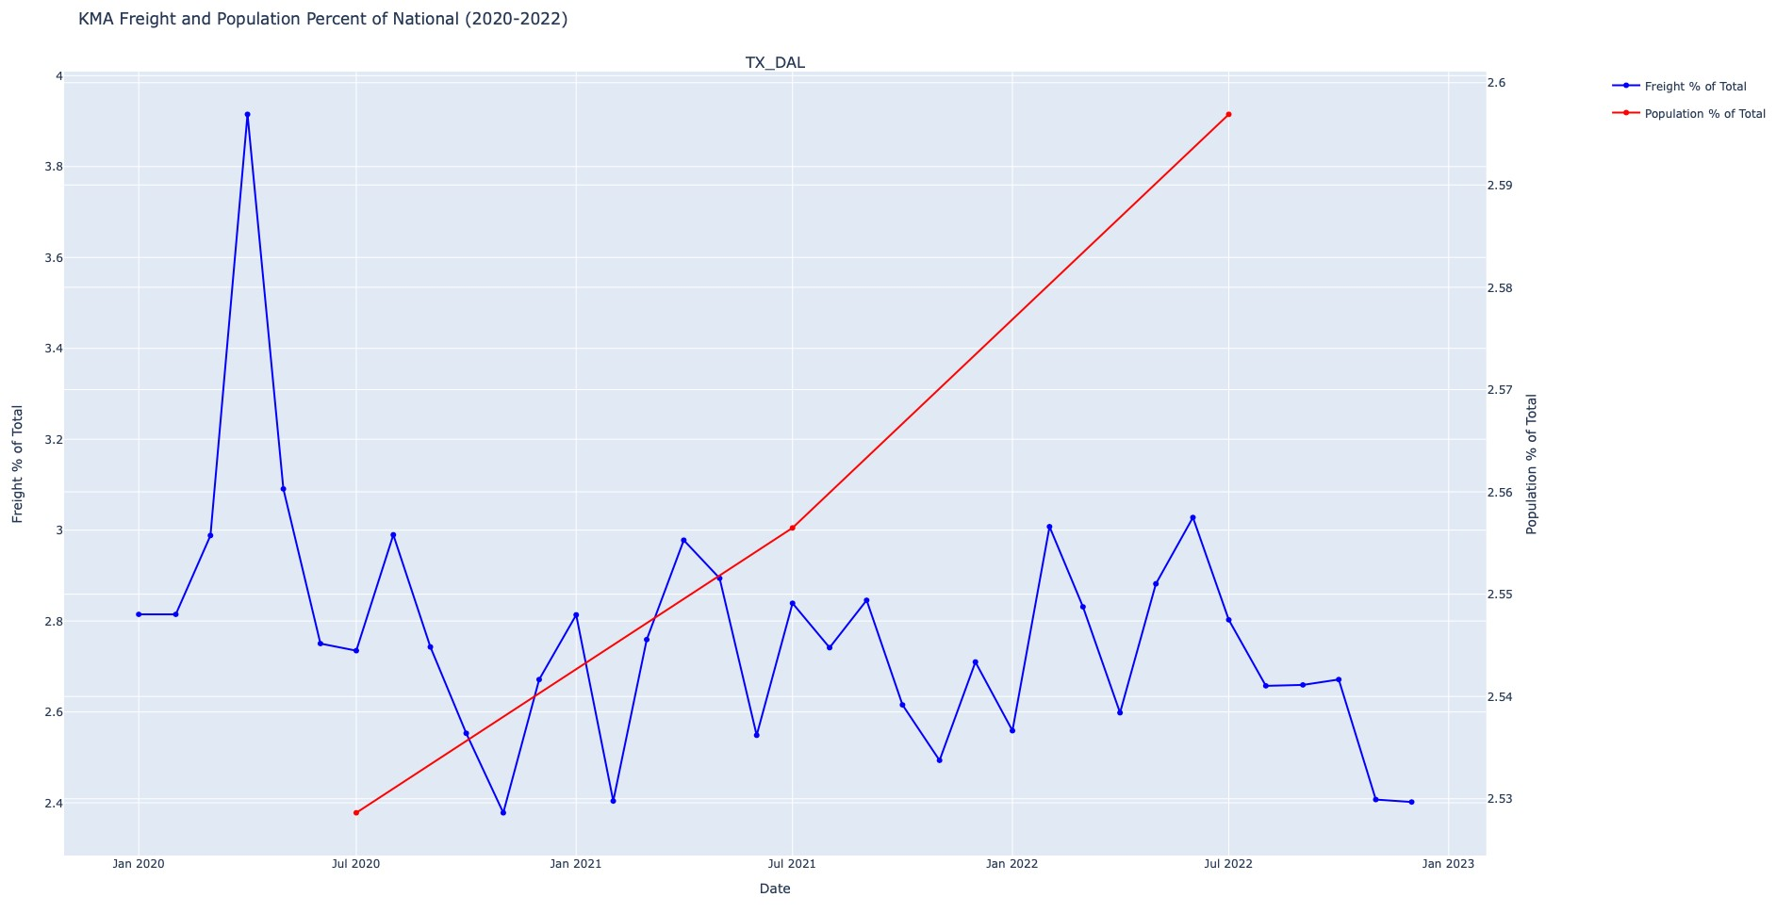Looking at some of the positive-negative population-freight relationships, there is a cluster of population increase from 2020 to 2022 in the Dallas and Houston KMAs, the second and third most positive population change from 2020 to 2022. Analyzing the “Top 20 KMA Freight Percent Change 2020-2022” map displays that the Dallas and Houston KMAs are decreasing in freight, with a change of -9.84% and -14.49%, respectively. Revisiting the TX_DAL and TX_HOU line graphs discussed previously, we can see a month-to-month visual that shows population increase across 2020-2022 and freight generally not following the increase of population but instead declining across 2020-2022. The TX_DAL and TX_HOU KMAs appear to be KMAs which do not exhibit possible examples of population impacts on freight, with a considerable gain in population and a loss in percentage of freight as demand for consumer goods increases.

**TX_DAL KMA Freight and Population Percent of National (2020-2022) Line Graph**

## TX_HOU KMA Freight and Population Percent of National (2020-2022) Line Graph

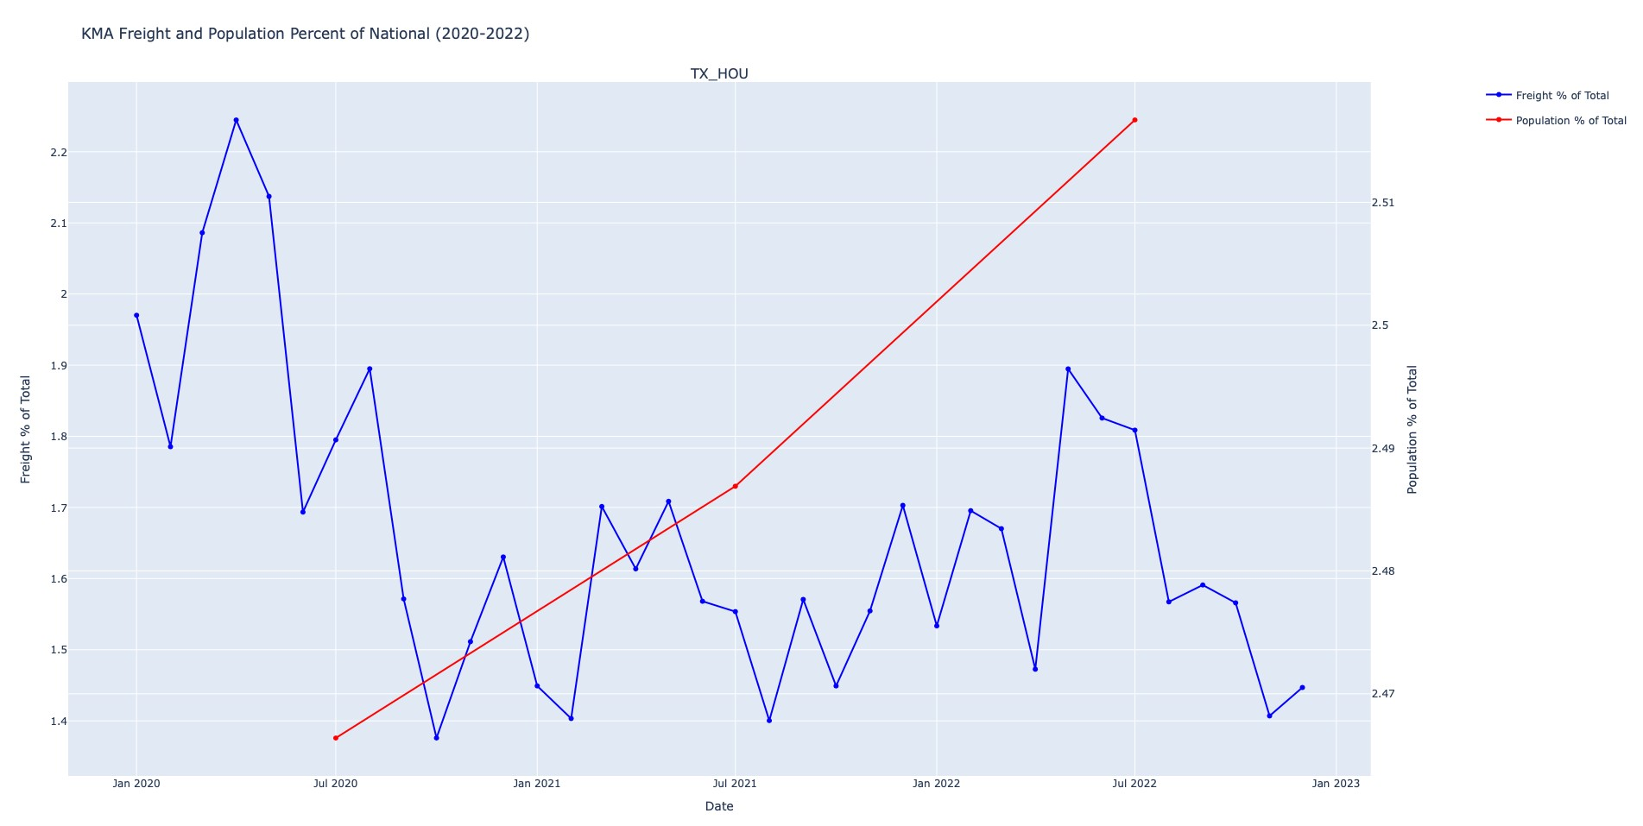Further analysis of the “Top 20 KMA Population Total Change 2020-2022” and “Top 20 KMA Freight Percent Change 2020-2022” maps uncovers a Southeast cluster of increasing population change but decreasing freight percent change. The KMAs of TN_NAS, GA_ATL, SC_GRE, SC_COL, NC_CHA, NC_RAL, FL_JAX, FL_LAK, and FL_MIA all experienced increases in population change from 2020 to 2022 but only three of them, SC_GRE, NC_CHA, and FL_LAK, saw increases in freight percent change from 2020 to 2022 with the SC_GRE freight percent increase only being 0.6%. The NC_CHA freight percent change increase of

13.61% is the most positive freight percent change increase of all KMAs from 2020 to 2022. With a cluster of increasing population change and a mix of increasing/decreasing freight percent change, a direct population impact on freight cannot be established for the cluster/region and their KMAs.

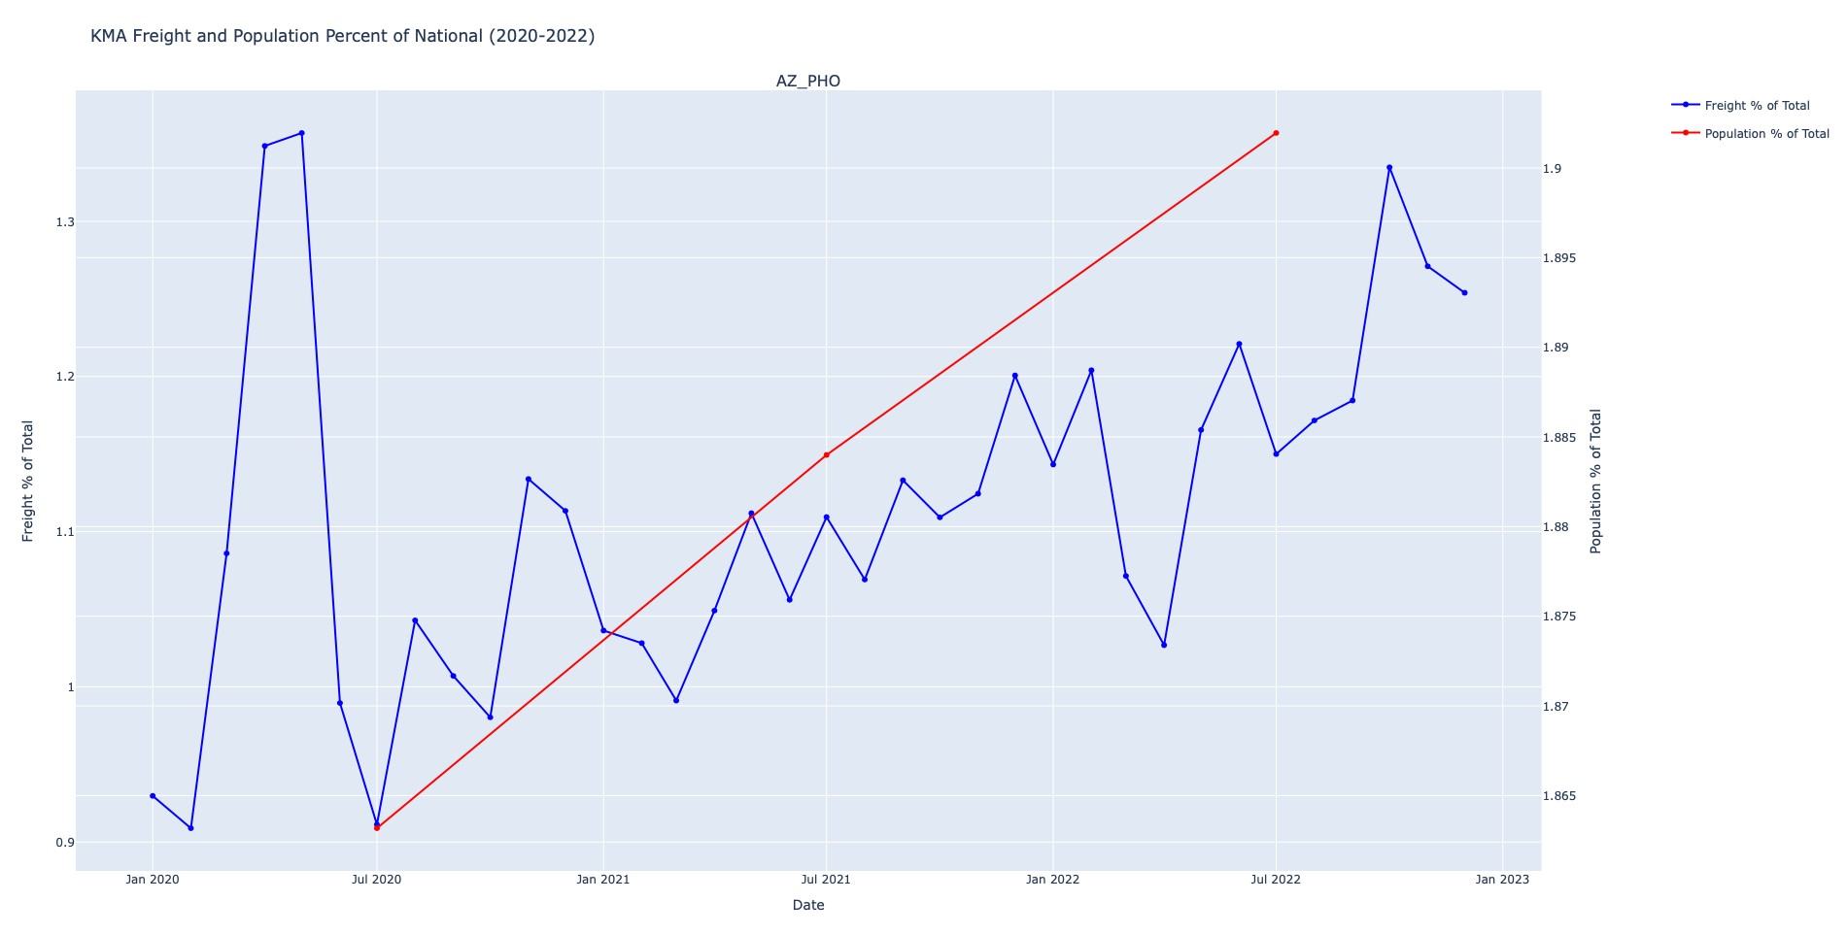Some other interesting KMA population-freight relationships exist in the Phoenix, San Antonio, Chicago, and Brooklyn KMAs. Phoenix experienced an increase in population change from 2020-2022 as well as an increase in freight percent change from 2020 to 2022. The Phoenix line graph displays freight increase following population increase, noting Phoenix as a KMA that appears to exhibit possible examples of direct population impact on freight.

San Antonio experienced an increase in population change from 2020-2022 like the other KMAs in the South cluster (Dallas, Houston, San Antonio, Austin), but was the only one to see an increase in freight percent change from 2020 to 2022. The San Antonio line graph displays freight increase following population increase, noting San Antonio as a KMA that appears to exhibit possible examples of direct population impact on freight.

**AZ_PHO KMA Freight and Population Percent of National (2020-2022) Line Graph**

## TX_ANT KMA Freight and Population Percent of National (2020-2022) Line Graph

The Chicago and Brooklyn KMAs both saw a decrease in population change from 20202022, with Brooklyn being the biggest loser in population change from 2020 to 2022 with a loss of 408,068 people. The Chicago and Brooklyn KMAs saw a similar decrease in freight percent change from 2020-2022, with Brooklyn landing as the fourth biggest loser in freight percent change from 2020 to 2022 with a loss of 17.48%.

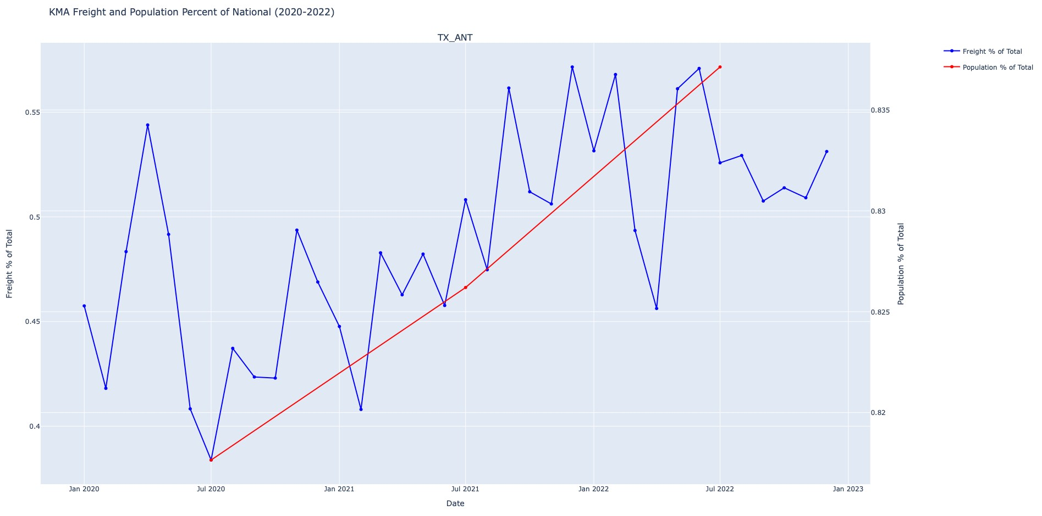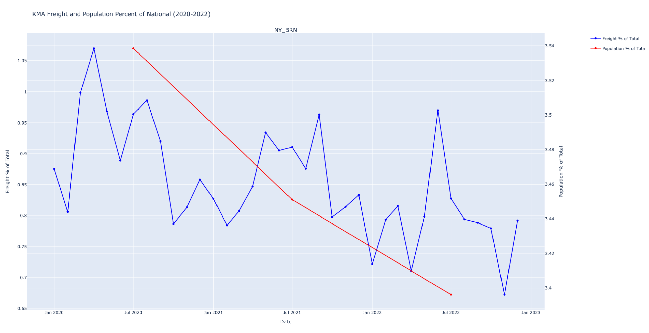

**NY_BRN KMA Freight and Population Percent of National (2020-2022) Line Graph**

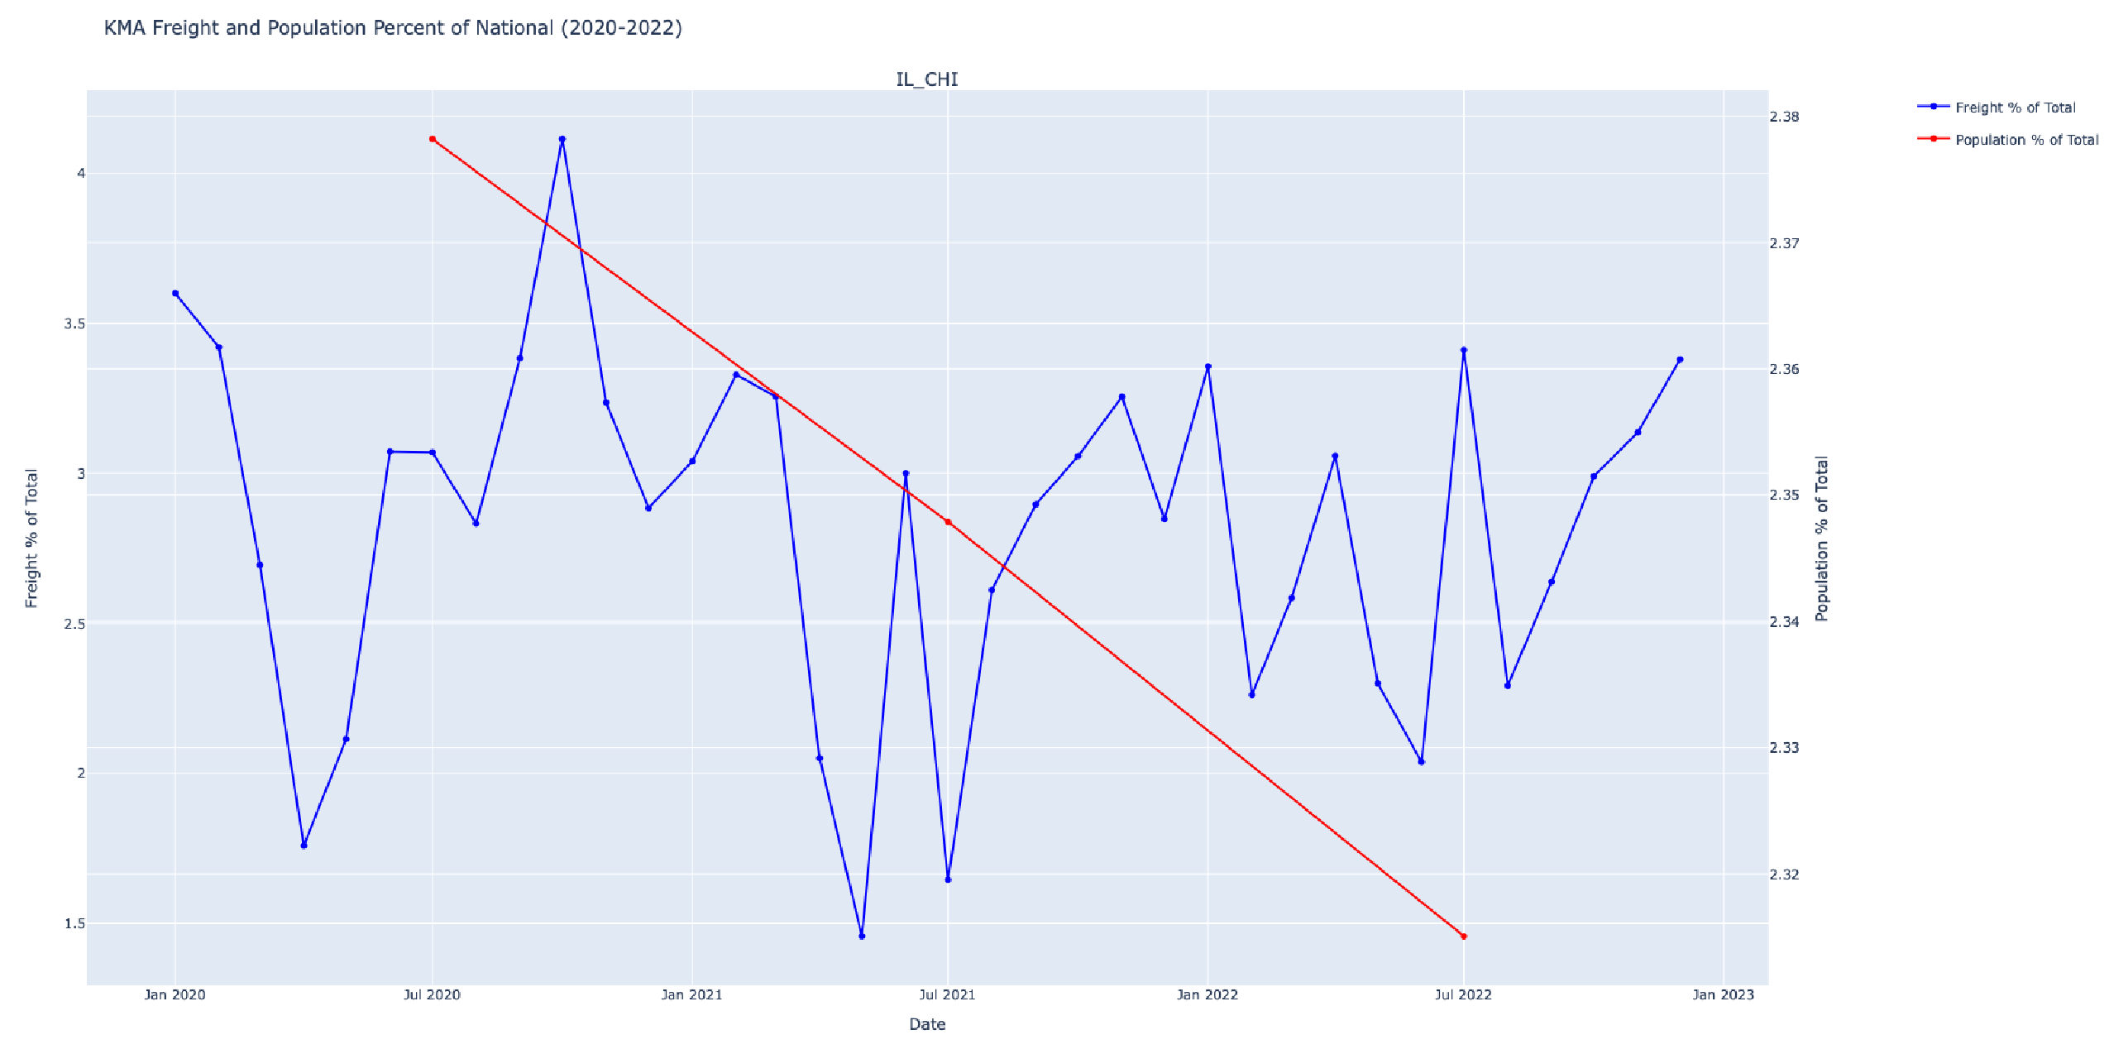The Chicago and Brooklyn line graphs do not display any kind of connection between population decrease and freight decrease, as the freight lines do not appear to be affected by the population line across 2020 to 2022 as the population strictly decreases and there are several instances of freight increasing at times where population is decreasing. Therefore, a direct population impact on freight cannot be established for the Chicago and Brooklyn KMAs. Other known contributing factors to decreasing freight change like economic loss should be explored to determine if an impact on freight percent change from 2020-2022 exists.

**IL_CHI KMA Freight and Population Percent of National (2020-2022) Line Graph**

Overall, the analysis of the “Top 20 KMA Population Total Change 2020-2022” and

“Top 20 KMA Freight Percent Change 2020-2022” maps offered the uncovering of clusters and interesting KMAs to be further explored to determine if a KMA appears to exhibit possible examples of direct population impact on freight. In many cases, further research and analysis must be performed to ensure that the population impact exists and is the direct cause of freight percent change, considering that there are several factors that can influence freight change as well as the discretion of timeframes. In this project, the KMAs examined were explained to

“exhibit possible examples of direct population impact on freight” due to the recent nature of the data being studied in this project (2020-2022).

# Conclusion

While the research conducted for this project was not able to establish a direct correlation between population migration and freight volume, it has uncovered noteworthy outliers and trends in population dynamics that merit attention for future research and freight flow planning. The findings suggest that population alone is not the sole driving factor in overall transportation flow, exemplified by instances where KMAs experienced significant population declines yet demonstrated robust industry performance, such as the automotive sector in Detroit, Michigan. This research underscores the importance of a nuanced approach, prompting consideration for additional analyses that differentiate between freight for consumer goods and other types of freight, particularly for large industries.

Despite inconclusive findings from this research, it is evident that significant population shifts are occurring, notably with a considerable loss of population from densely populated cities such as New York, Chicago, and San Francisco to the Southeast, resulting in notable population increases in cities across Florida, the Carolinas and Georgia. Data also suggests that the top 20

KMAs identified for this research alongside others could very well be acting as “hub” KMAs, KMAs to which a large volume of freight is being delivered to, from which freight will be delivered out of to various other KMAs.

In light of these findings, future research endeavors should delve deeper into specific sectors of freight and their responses to population migration, fostering a more comprehensive understanding of the intricate relationship between demographic shifts and freight dynamics. For example, if one is interested in establishing a distribution center for consumer packaged goods, it would be worthwhile to look at top destination KMAs for freight hauling consumer packaged goods and observe where there are large population increases and if freight increases in response. This nuanced perspective will contribute to more informed freight flow planning and strategic decision-making in the evolving landscape of population and industry distribution.

|  |  |  |  |  |
| --- | --- | --- | --- | --- |
|  |  | Top 20 KMAs | |  |
| Rank | KMA Name |  | Population Change 2020-2022 | Freight Volume  Percent Change 2020-  2022 |
| 1. | NY_BRN |  | -408,068 | -17.48% |
| 2. | FL_LAK |  | 331,497 | 5.35% |
| 3. | TX_DAL |  | 271,235 | -9.84% |
| 4. | CA_FRS |  | -249,510 | -27.07% |
| 5. | CA_SFR |  | -240,713 | -31.51% |
| 6. | TX_HOU |  | 210,638 | -14.49% |
| 7. | IL_CHI |  | -166,520 | -13.61% |
| 8. | FL_JAX |  | 166,220 | -16.63% |
| 9. | AZ_PHO |  | 161,667 | 6.96% |
| 10. | TX_AUS |  | 155,647 | -3.77% |
| 11. | GA_ATL |  | 153,576 | -14.78% |
| 12. | NC_CHA |  | 119,045 | 13.61% |
| 13. | FL_MIA |  | 116,300 | -8.18% |
| 14. | UT_SLC |  | 96,741 | -11.10% |
| 15. | TX_ANT |  | 79,119 | 10.98% |
| 16. | TN_NAS |  | 71,351 | -17.10% |
| 17. | ID_TWI |  | 69,731 | -19.84% |
| 18. | SC_GRE |  | 62,399 | 0.60% |
| 19. | NC_RAL |  | 56,997 | -25.48% |
| 20. | SC_COL |  | 54,150 | -16.17% |

**Top 20 Key Market Areas by Absolute Change (2020-2022)**